# 

# 

# CS 3340 – Introduction to OOP and Design

# Project 3 - Android Application

**Pedometer and BMI Calculator Using GPS**

# Documentation

Gayathiri Shriram (MS5754)

Shravya Mahankali (GE5327)

Sahil Chopra

## Description:

### A.1) List of Classes:

* Home.java – Main class that depicts all the functionality of the application.

It shows the steps, duration, speed, distance, calories and frequency. Result of the application is displayed in this class.

* Userdata.java – User data class is used to get the data from the user and calculate the BMI. Details like height, weight, age and gender is received as input from the user and result is displayed on the screen.
* Userprogress.java - User progress is another class used to show the progress of the user through a graphical representation.
* GeoLocator.java – This class tracks the path of the user. Google map is used in this class. Also the latitude and longitude of the location is used to track the location path.
* GPSActivity.java – This class gives the current location of the user using GPS. GPSTracker class is used.
* GPSTracker.java – Extension class that supports the GPSActivity.java class.
* ExampleUnitTest.java – Unit test case is used in this unit test framework.

### A.2) State of System:

Pedometer and BMI calculator using GPS is an android application developed to track the users workout also provides details of their body fitness in terms of BMI. We have developed two features to enhance this app. One is a path finder which is help the user find and track his path and another one is GPS locator to indicate the location of the workout.

#### Working Functionalities:

* App loading is working as expected on both emulator and device.
* Pedometer displaying the Steps, Duration, Speed, Distance, Calories, and Frequency is working as expected. The data is displayed after end work out is button pressed.
* BMI calculator named as user data is also working as expected. Weight, height, gender and age are got as input from user and BMI is calculated.
* Graphical representation of the user progress based on the work out is also working as expected.

#### Not Working Functionalities:

* GPS tracker used to track the location of the user is not working as expected. We tried it on both emulator and the device. Upon clicking the GPS tracker option from the menu the system crashes and the app is closes.
* Geo locater is another functionality that is not working as expected. We designed it to act as a pathfinder to the user. Upon clicking the Geo Locater option from the menu the system crashes and the app closes.

**Debugging Screen Shots**

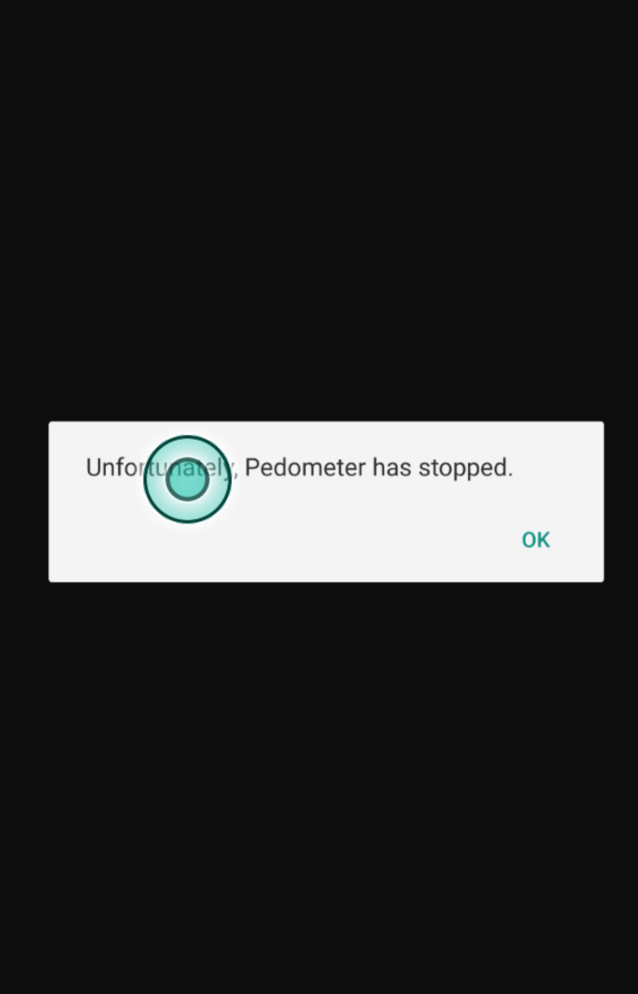

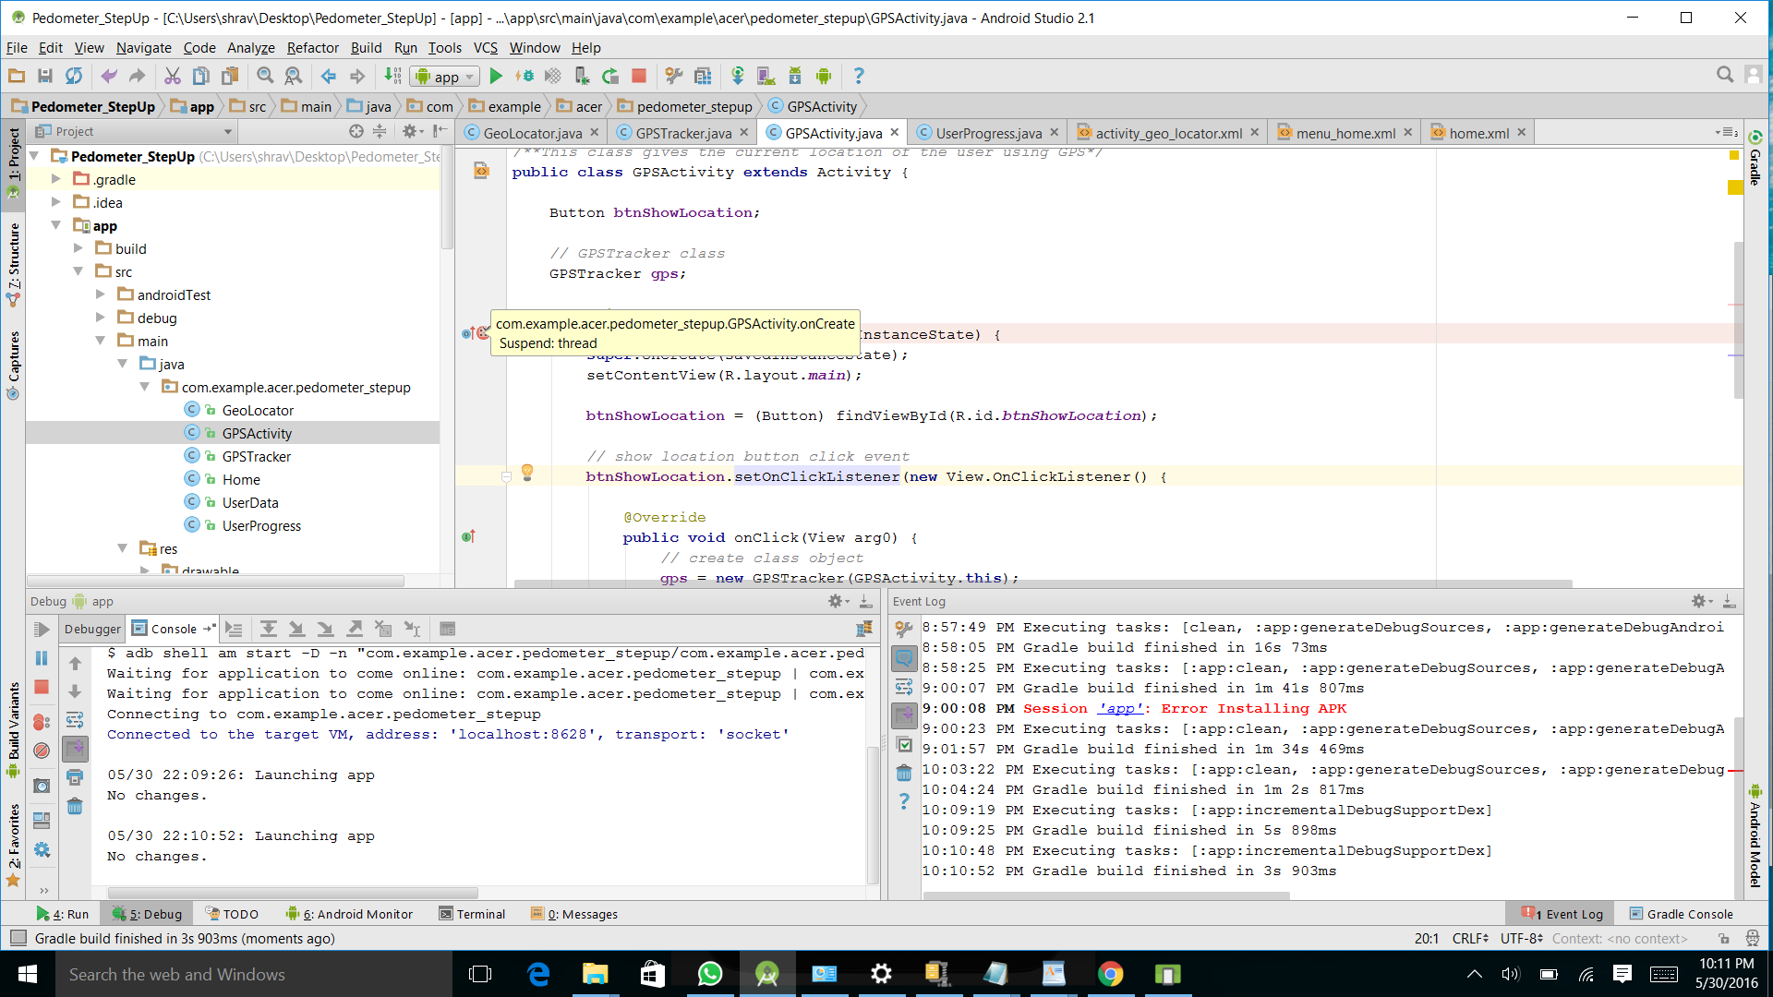

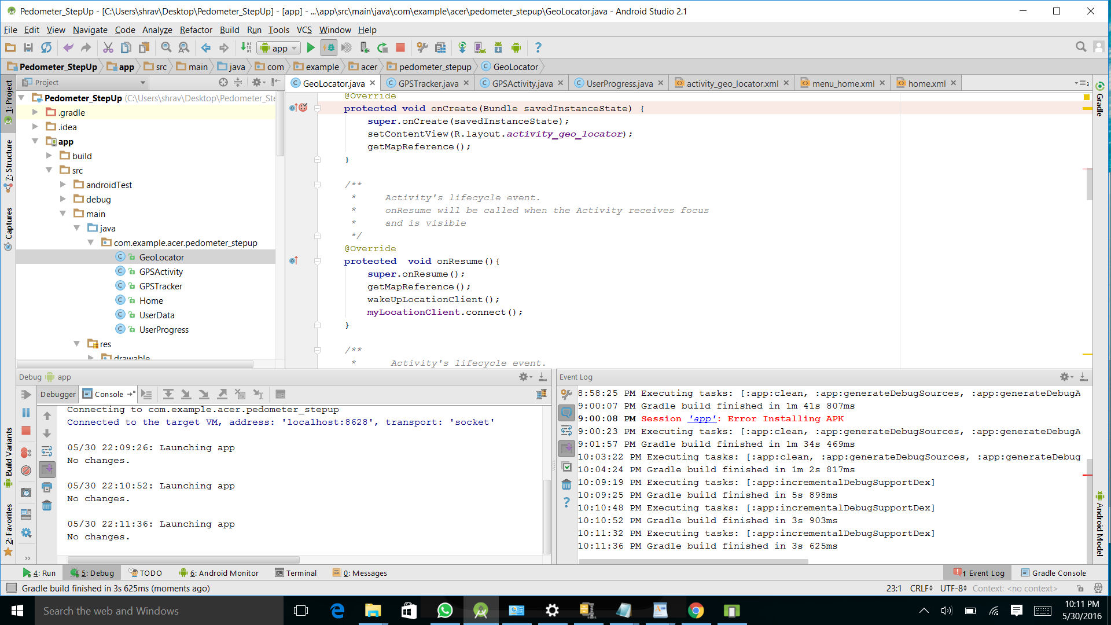

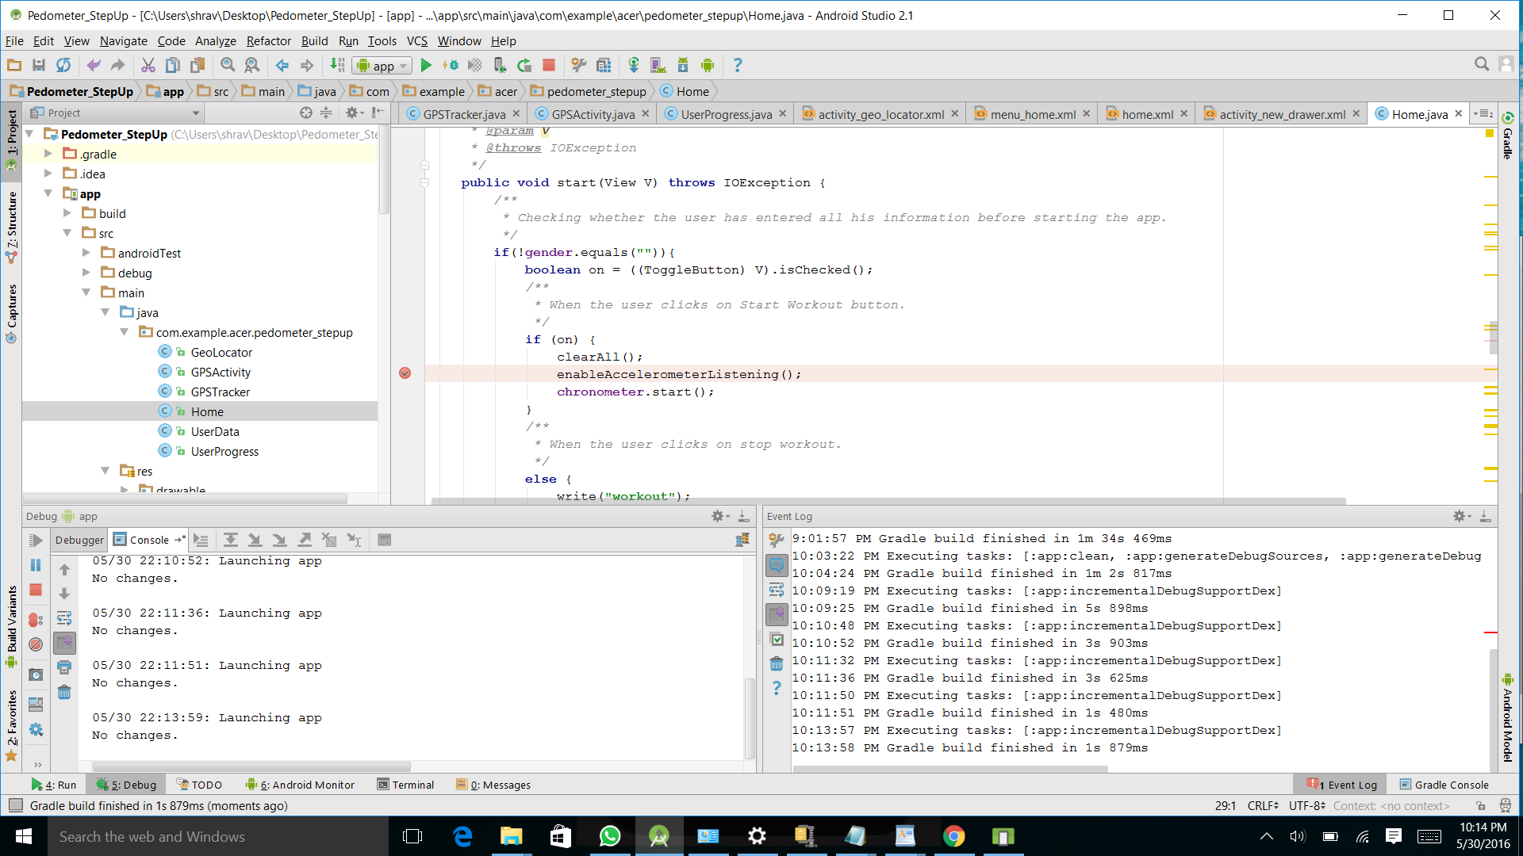

## URL: Posting of Javadoc to server account

## http://puzzle.sci.csueastbay.edu/~ms5754/project3/

## C. UML / Design

### C.1) UML Class Hierarchy Diagram

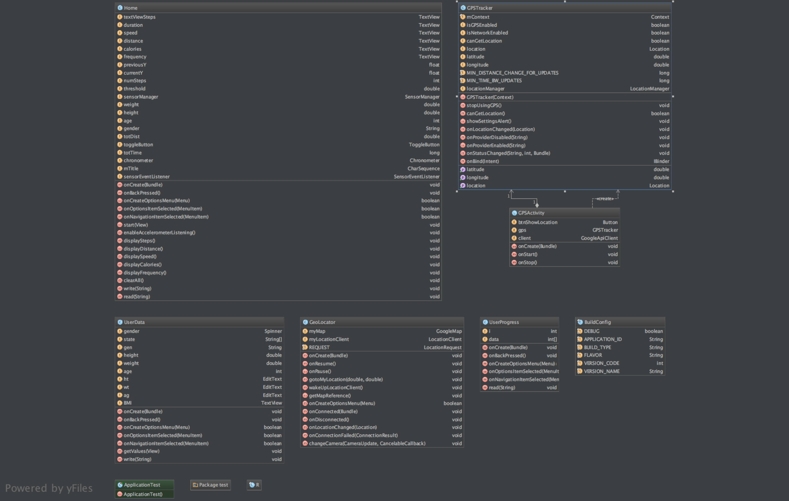

## D. Working Screen shots:

### D.1) Work Instance 1: Loading of Application

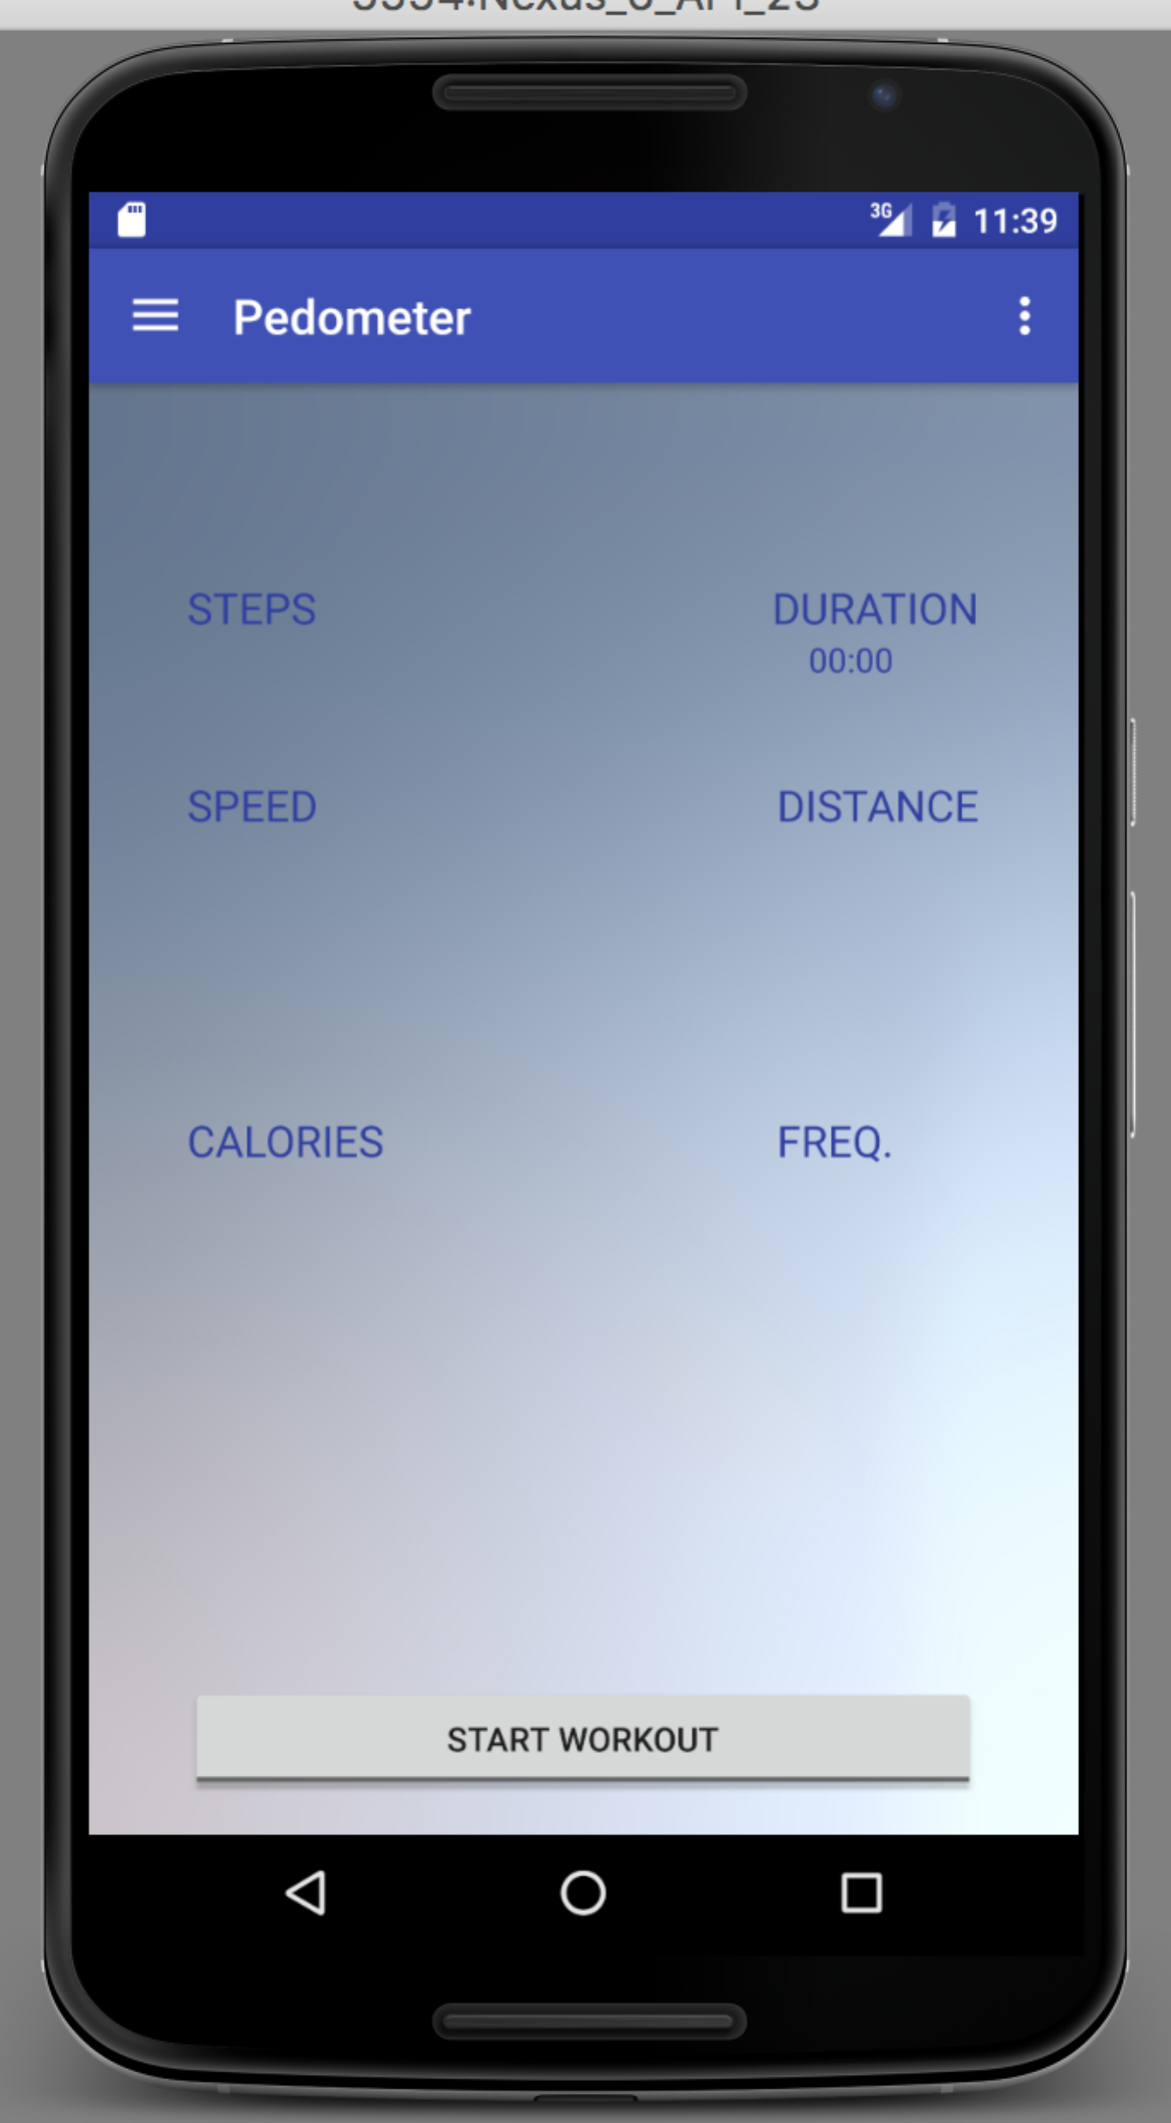

### D.2) Work Instance 2: Available Menu Option

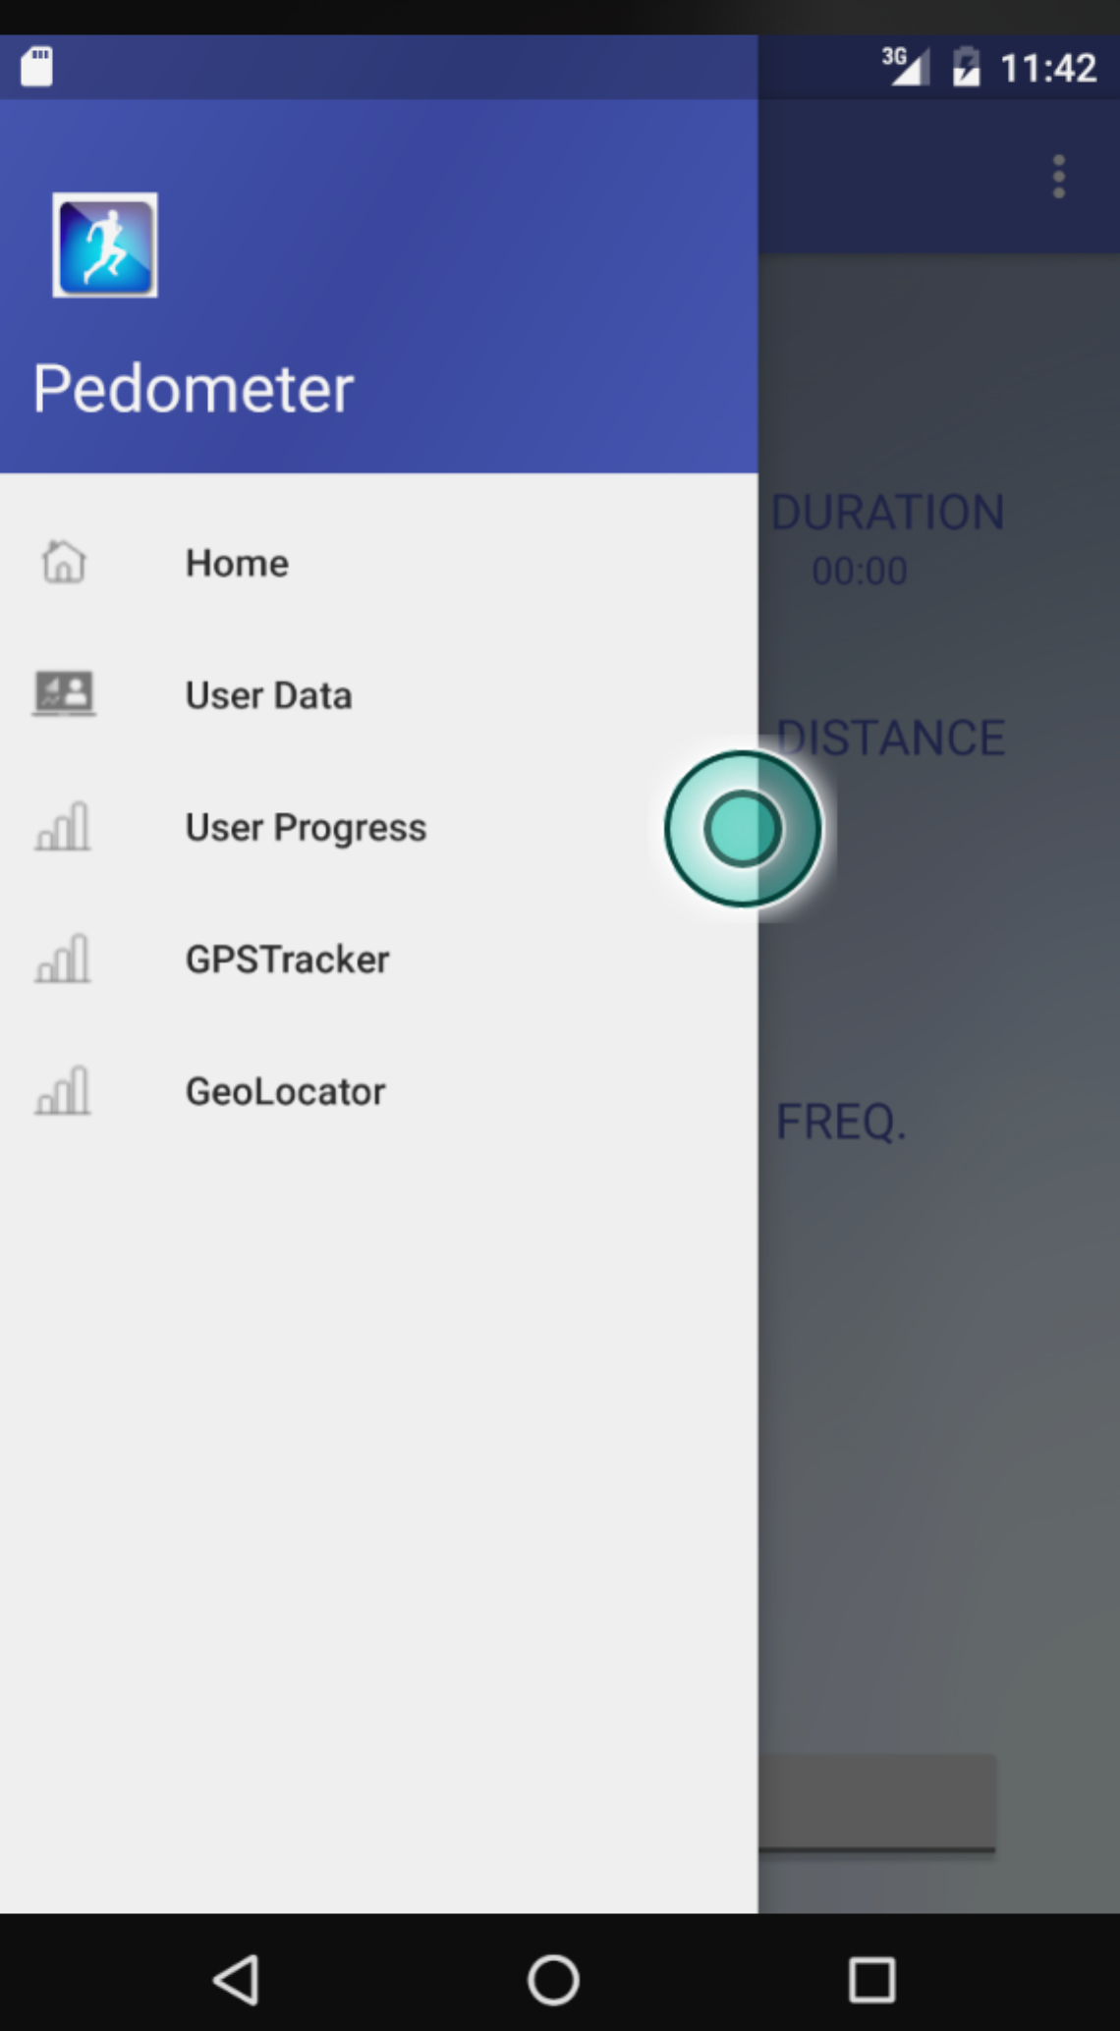

### D.3) Work Instance 3 - User Data Input and BMI calculation

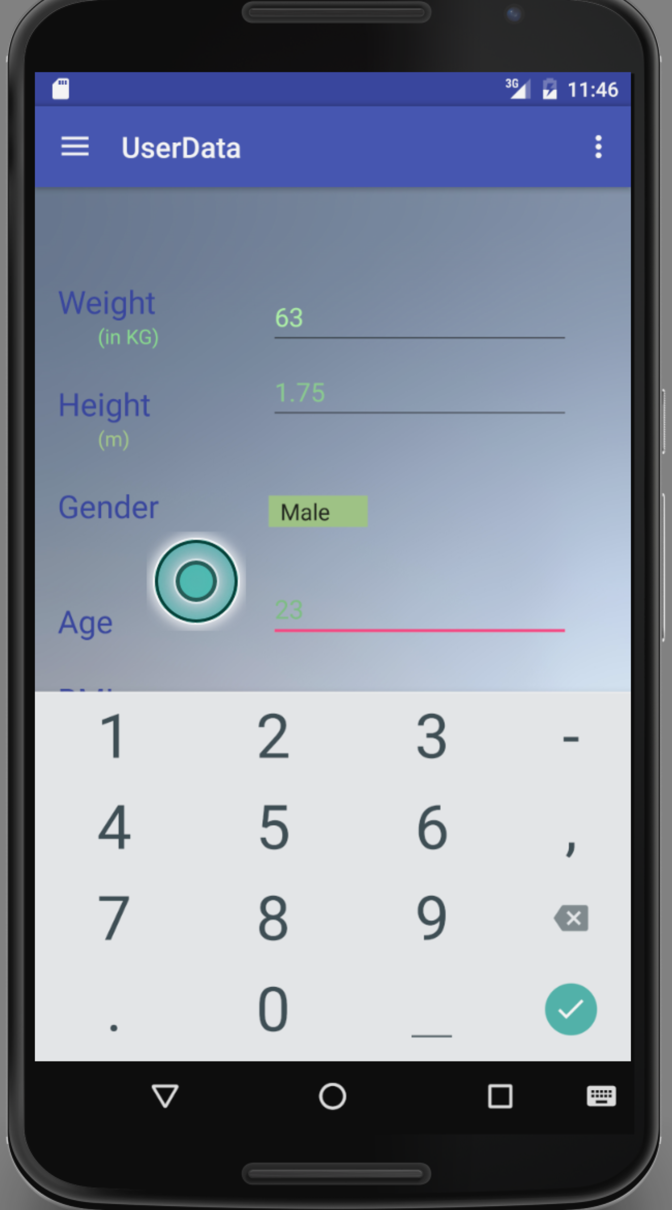

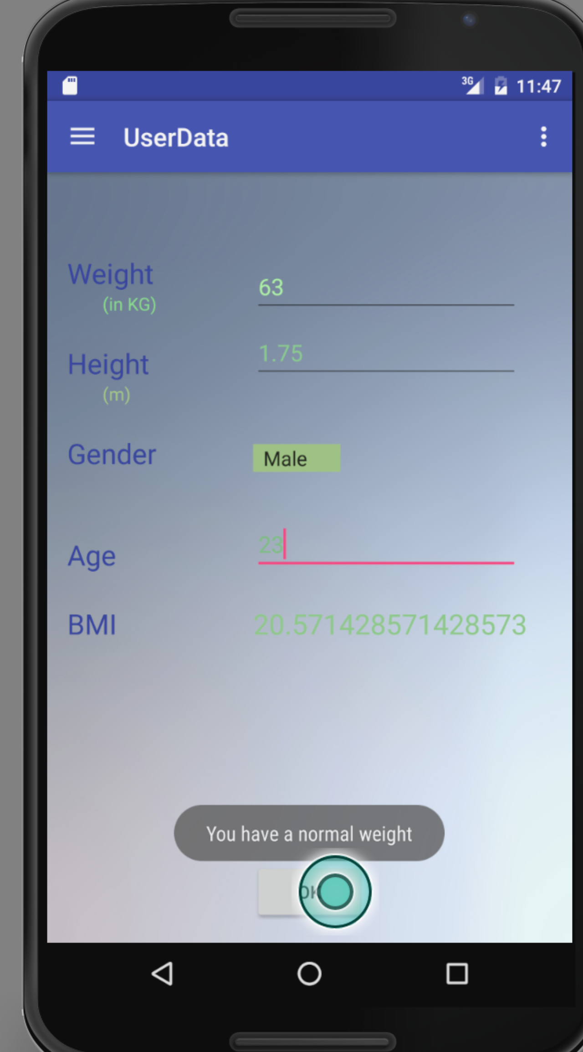

### D.4) Work Instance 4: Starting workout

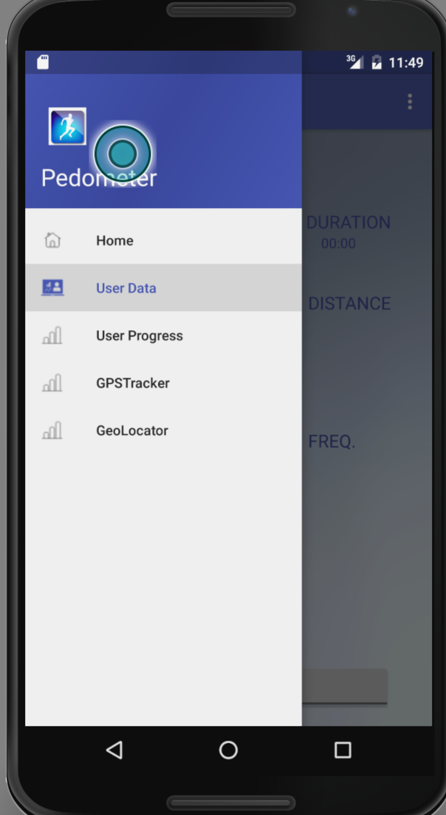

### D.5) Work Instance 5: Stopping the workout

### D.6) Work Instance 6: Result of the Workout

### D.7) Work Instance 7: User Progress

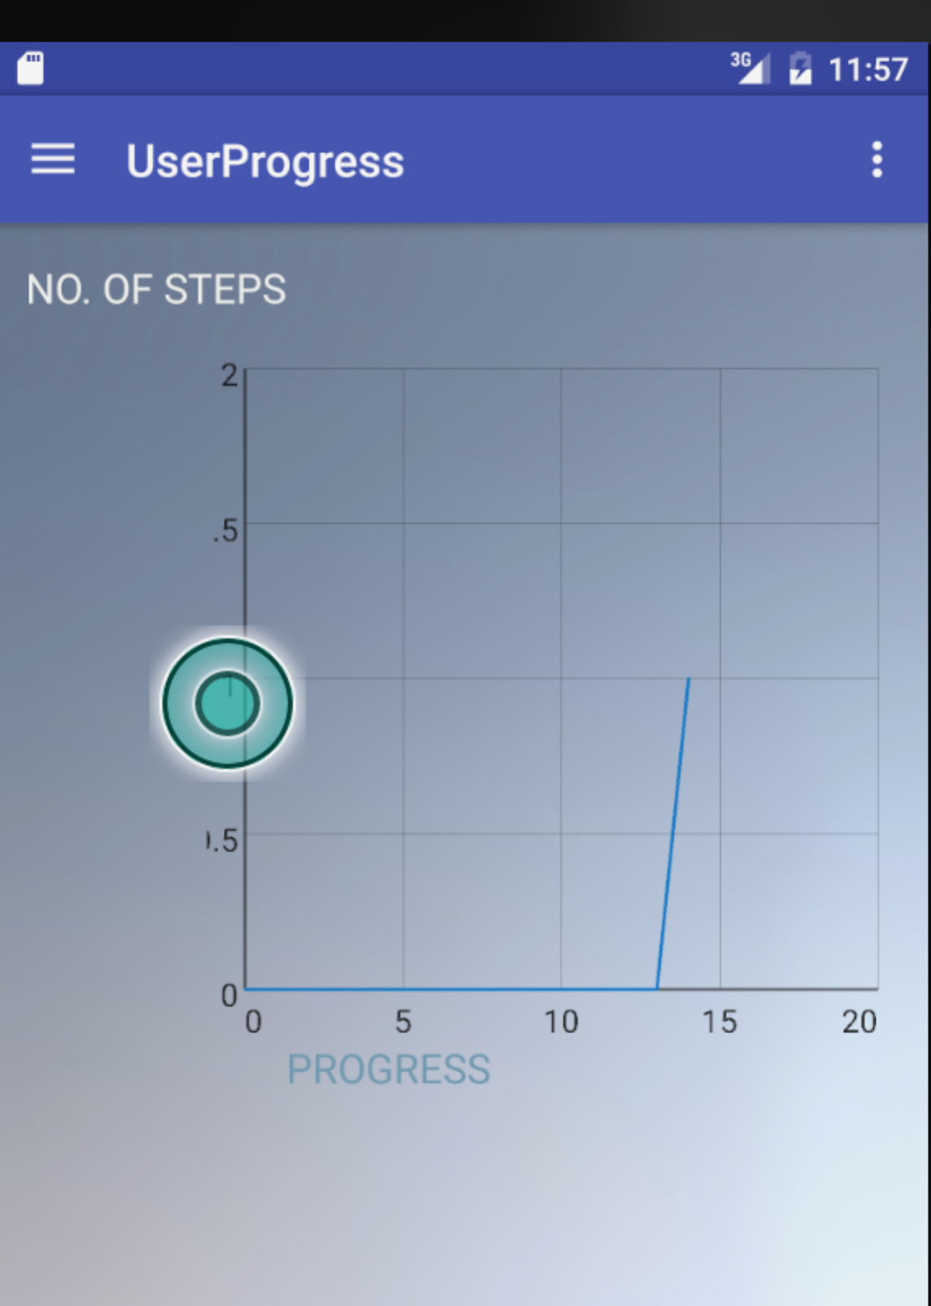

## E. URL to Youtube Demonstration of App:

<https://www.youtube.com/watch?v=f7bJ-jikvK0>

**BitBucket URL**- <https://bitbucket.org/gayathirishriram/pedometer-and-bmi-calculator-using-gps/admin>